**MS SQL SERVER**

**Standard Operating Procedures**

**(SOP)**

**Import and export of data**

Submitted to



**By**



CIS, Wipro Limited

Document Details

|  |  |
| --- | --- |
| Project Name | Innogy SE |
| Account | CIS |
| IT Component/Application Title | Import and export of data |
| Current Version | 1.2 |
| List of Contributors | Pradipkumar Kansara, Kiran Bhalekar, Ayushi Gautam, Sivakumar Goud, Pramod Patil |
| Customer Contact Information |  |

Version History

(All revisions made to this document must be listed in chronological order. All revisions must be approved. Review and Approval can be done by an internal source or by the customer)

|  |  |  |  |  |  |
| --- | --- | --- | --- | --- | --- |
| Version | Date of Revision | Description | Author | Reviewed By | Approved By |
| 1.0 | 08-12-2017 | Initial Draft | Kiran Bhalekar | Pradipkumar Kansara | Santosh Badiger |
| 1.1 | **13-12-2017** | **Document Completed** | **Kiran Bhalekar** | **Pradipkumar Kansara** | **Santosh Badiger** |
| 1.2 | **25-12-2018** | **Updated the content** | **Pramod Patil** | **Pradipkumar Kansara** | **Santosh Badiger** |

Document Distribution List

|  |  |  |
| --- | --- | --- |
| **Sr.No** | **Name and Company** | **Purpose** |
| **1** | RWEIT-SQLDBA | **This document is useful for understanding the steps which are involved to do data import/export** |

**TABLE OF CONTENT**

1. Purpose 4

2. Scope 4

3. Import/Export concepts 4

4. Steps for importing and exporting data 5

5. Reference 19

# 

# Purpose

This document is to cover import and export concepts of data which resides in database. This will help you in understanding the steps involved in importing/exporting the data.

# Scope

This document is prepared for GSMC Wipro sustenance team and provides the concepts of import/export of data.

# Import/export concepts:

SQL Server Import and Export Wizard is a simple way to copy data from a source to a destination. This overview describes the data sources that the wizard can use as sources and destinations, as well as the permissions you need to run the wizard.

This topic describes the sequence of steps for importing and exporting data with the SQL Server Import and Export Wizard. It also contains links to the individual pages of documentation that describe each page or dialog box you see in the wizard.

This topic describes only the **steps** in the wizard.

# Steps for importing and exporting data:

Following are the steps for importing and exporting data and the corresponding pages of the wizard. Depending on the options that you select in the wizard you will see different options as shown in below screenshot:

Few things you have to keep in mind before doing import/export:

1. You should know when to do import
2. You should know when to do export
3. You should aware about your source and destination data/table/files
4. You should aware about data format like excel/msaccess/sql/oledb

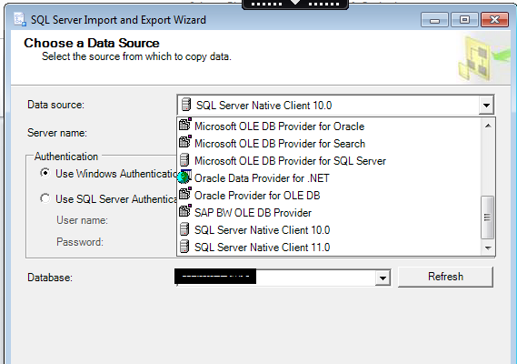

## Here's the Excel source data for this example

Here's the source data that you're going to copy - a small two-column table in the WizardWalkthrough worksheet of the WizardWalkthrough.xlsx Excel workbook.

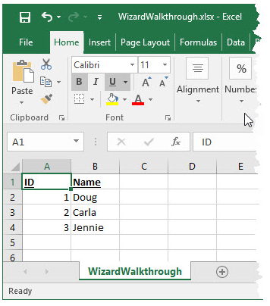

## Here's the SQL Server destination database for this example

Here (in SQL Server Management Studio) is the SQL Server destination database to which you're going to copy the source data. The destination table isn't there - you're going to let the wizard create the table for you.

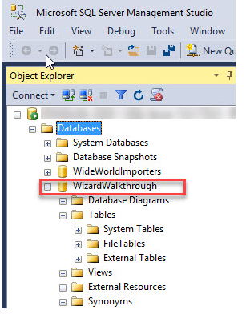

## Start the wizard

You start the wizard from the Microsoft SQL Server 2014 as per below screenshot

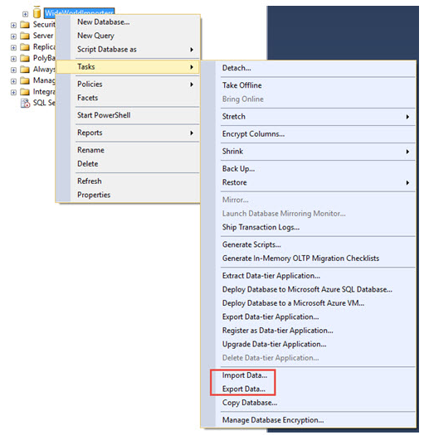

## View the Welcome page

The first page of the wizard is the **Welcome** page.

You probably don't want to see this page again, so go ahead and click **Do not show this starting page again**.

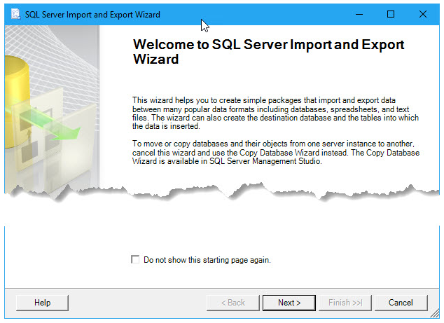

## Pick Excel as your data source

On the next page, **Choose a Data Source**, you pick Microsoft Excel as your data source. Then you browse to pick the Excel file. Finally you specify the Excel version that you used to create the file.

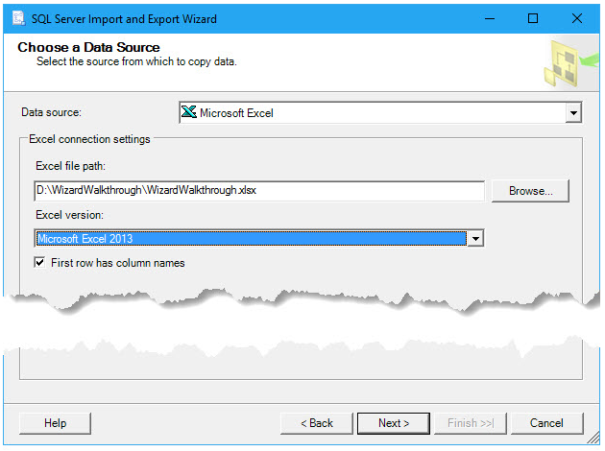

## Pick SQL Server as your destination

On the next page, **Choose a Destination**, you pick Microsoft SQL Server as your destination by picking one of the data providers in the list that connects to SQL Server.

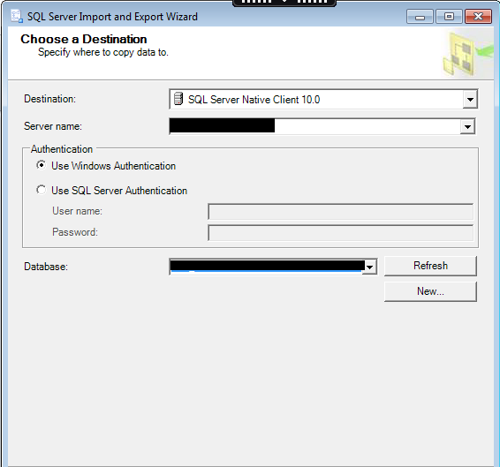

## Copy a table instead of writing a query

On the next page, **Specify Table Copy or Query**, you specify that you want to copy the entire table of source data. You don't want to write a query in the SQL language to select the data to copy.

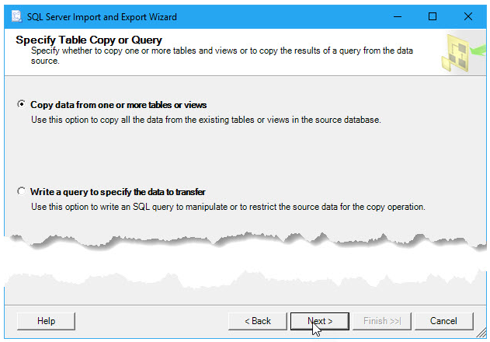

## Pick the table to copy

On the next page, **Select Source Tables and Views**, you pick the table or tables that you want to copy from the data source. Then you map each selected source table to a new or existing destination table.

In this example, by default the wizard has mapped the **WizardWalkthrough$** worksheet in the **Source** column to a new table with the same name at the SQL Server destination. (The Excel workbook only contains a single worksheet.)

* The dollar sign ($) on the name of the source table indicates an Excel worksheet. (A named ranged in Excel is represented by its name alone.)
* The starburst on the destination table icon indicates that the wizard is going to create a new destination table.

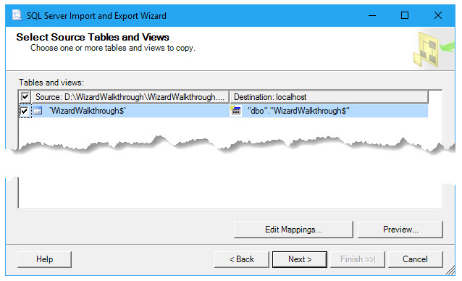

You probably want to remove the dollar sign ($) from the name of the new destination table.

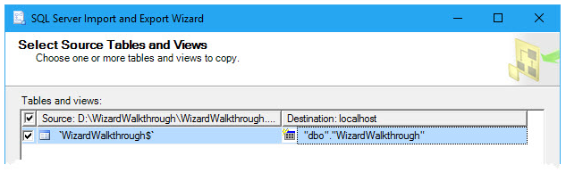

## Review the column mappings

Before you leave the **Select Source Tables and Views** page, optionally click the **Edit Mappings** button to open the **Column Mappings** dialog box. Here, in the **Mappings** table, you see how the wizard is going to map columns in the source worksheet to columns in the new destination table.

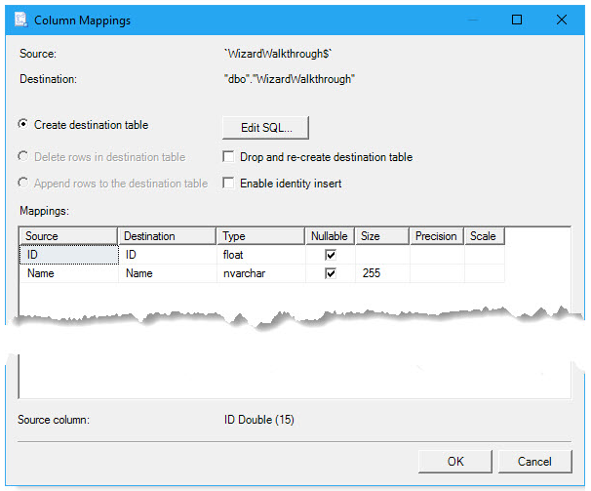

## Yes, you want to run the import-export operation

On the next page, **Save and Run Package**, you leave **Run immediately** enabled to copy the data as soon as you click **Finish** on the next page. Or you can skip the next page by clicking **Finish** on the **Save and Run Package** page.

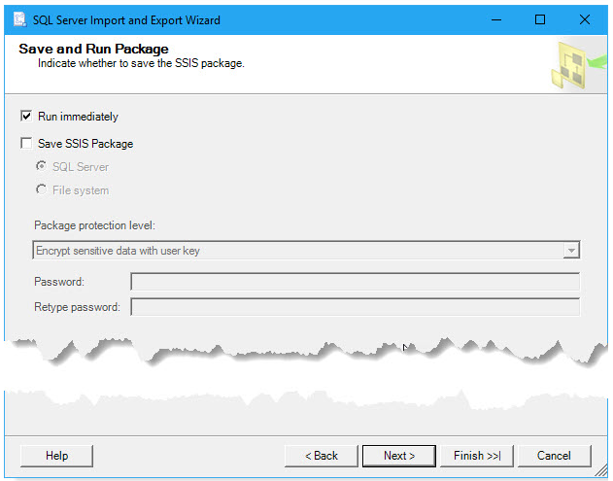

## Finish the wizard and run the import-export operation

If you clicked **Next** instead of **Finish** on the **Save and Run Package** page, then on the next page, **Complete the Wizard**, you see a summary of what the wizard is going to do. Click **Finish** to run the import-export operation.

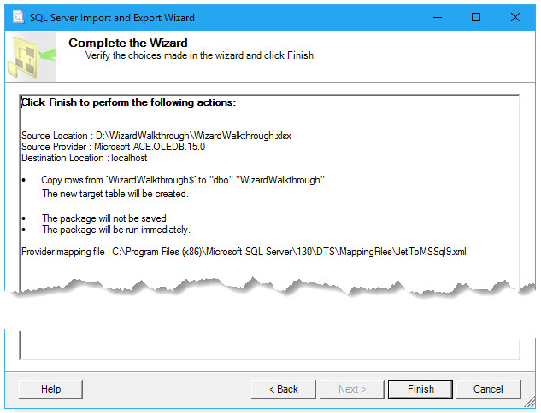

## Review what the wizard did

On the final page, watch as the wizard finishes each task, then review the results. The highlighted line indicates that the wizard copied your data successfully. You're finished!

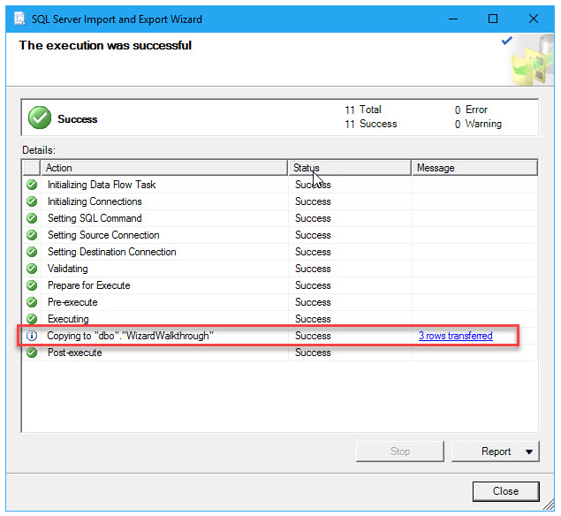

## Here's the new table of data copied to SQL Server

Here (in SQL Server Management Studio) you see the new destination table that the wizard created in SQL Server.

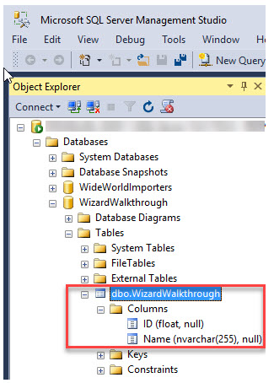

Here (again in SSMS) you see the data that the wizard copied to SQL Server.

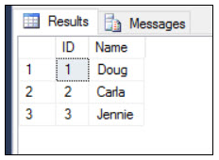

# References:

<https://docs.microsoft.com/en-us/sql/integration-services/import-export-data/steps-in-the-sql-server-import-and-export-wizard>

<https://docs.microsoft.com/en-us/sql/integration-services/import-export-data/get-started-with-this-simple-example-of-the-import-and-export-wizard>

<https://docs.microsoft.com/en-us/sql/integration-services/import-export-data/welcome-to-sql-server-import-and-export-wizard>